**VAISHALI BOKADIYA**

**PYSPARK DAY 3 ASSESSMENT**

**NOTES:**

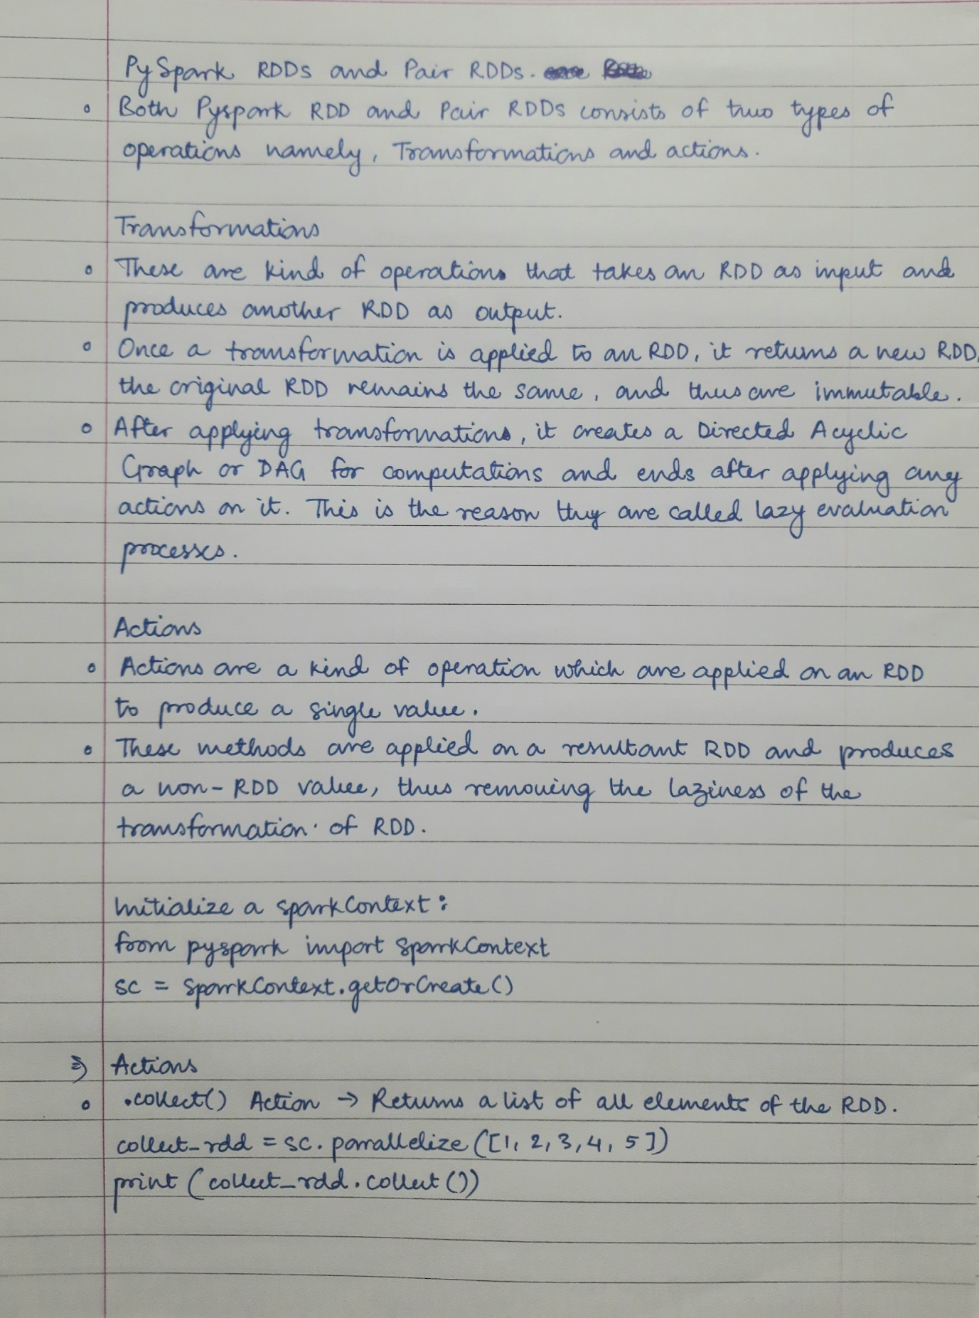

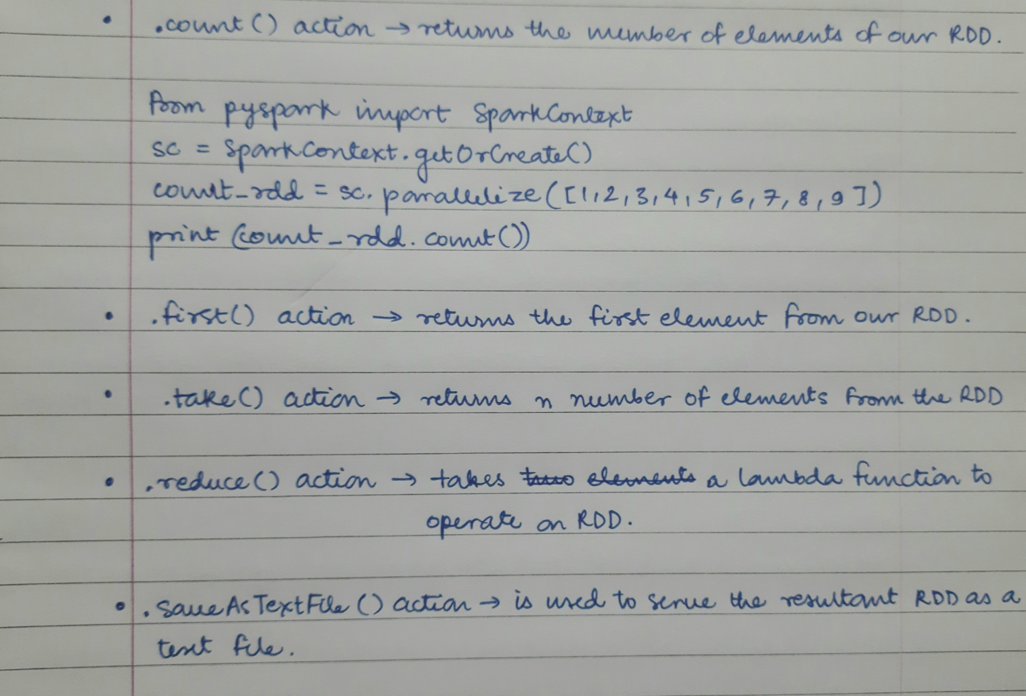

**Pyspark Practice:**

**RDD Actions:**

* **.collect(): Returns a list of all elements of the RDD.**

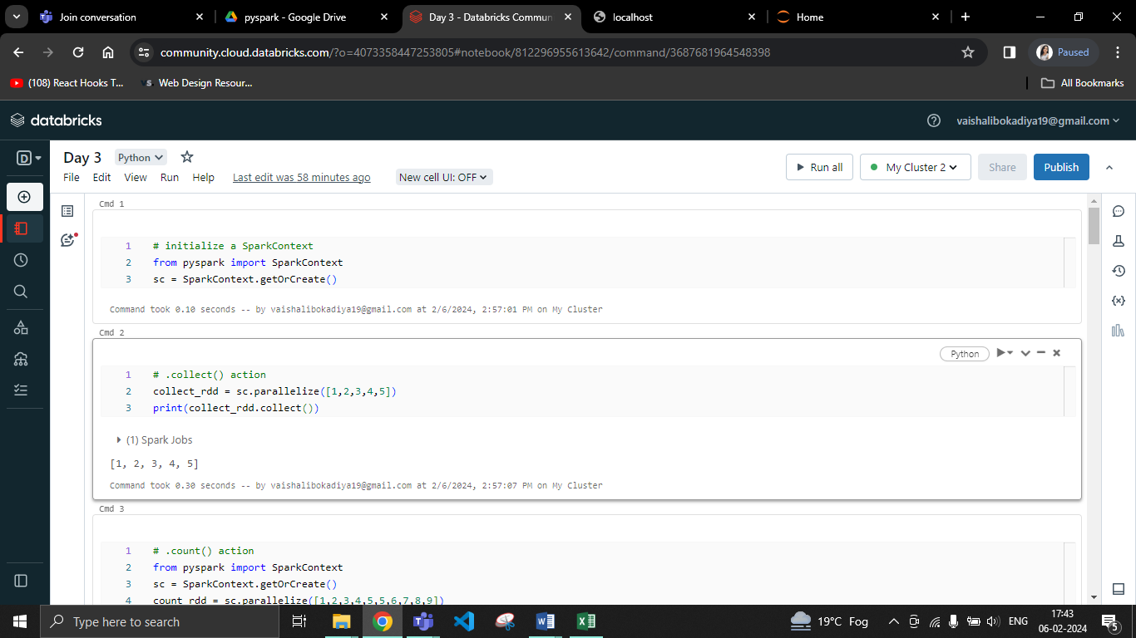

* **.count(): Returns the number of elements in RDD.**
* **.first(): Returns the first element from the RDD.**

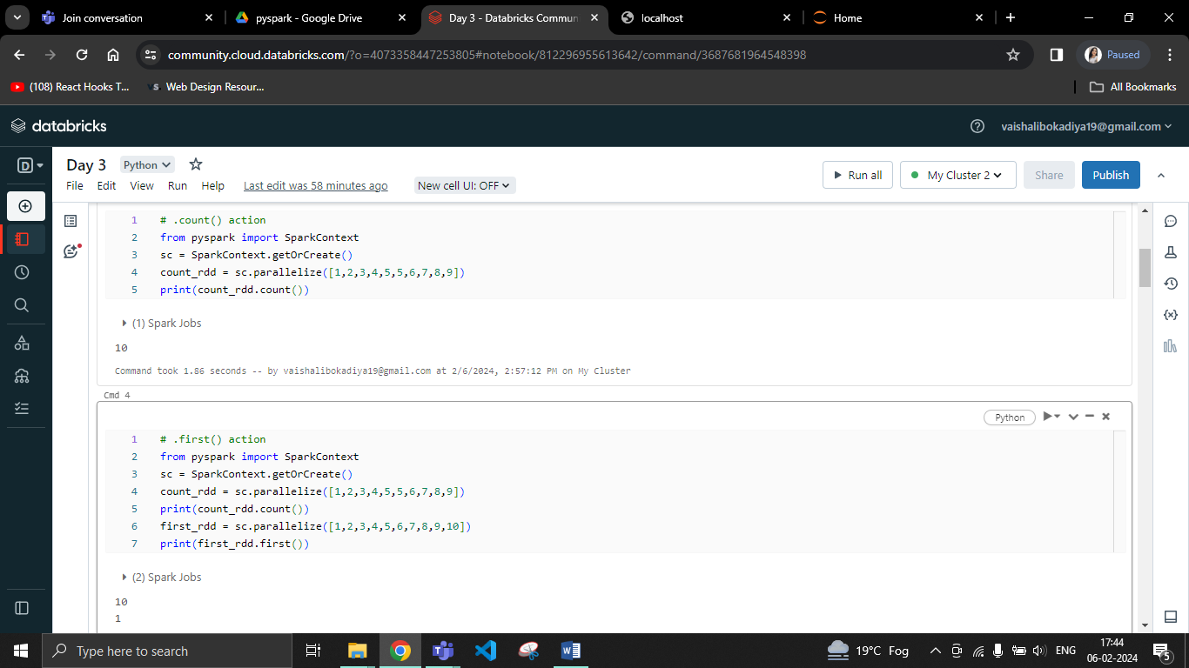

* **.take(): Returns n number of elements from the RDD.**
* **.reduce(): Returns result after performing a function on it.**

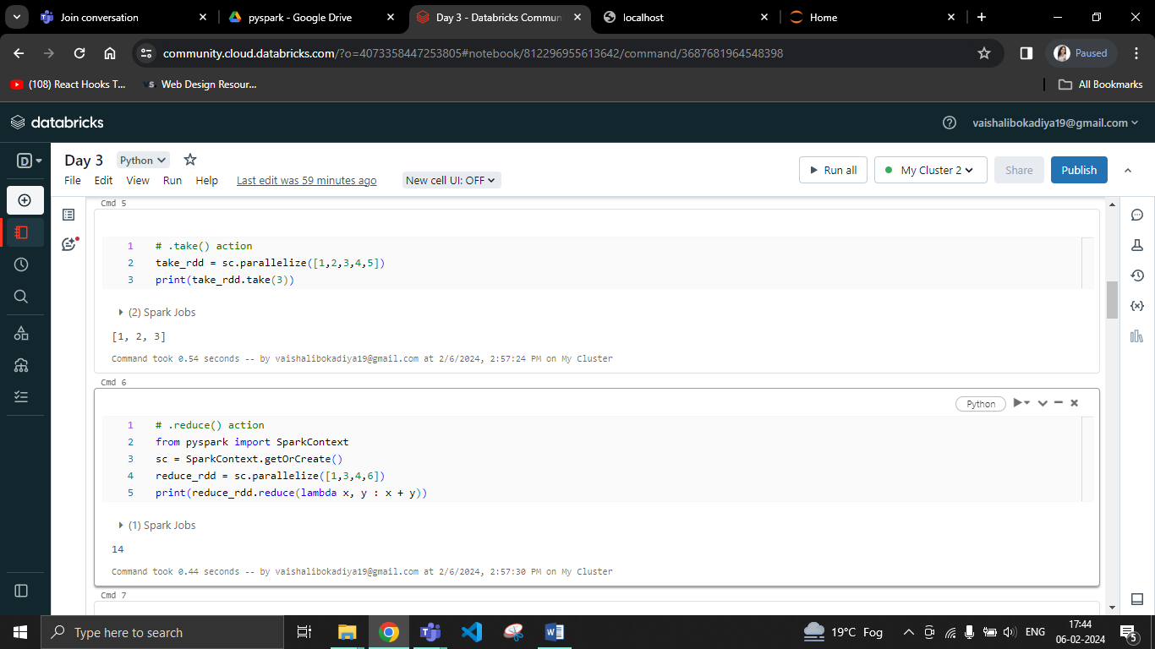

* **.saveAsTextFile(): Saves the resultant RDD as text file.**

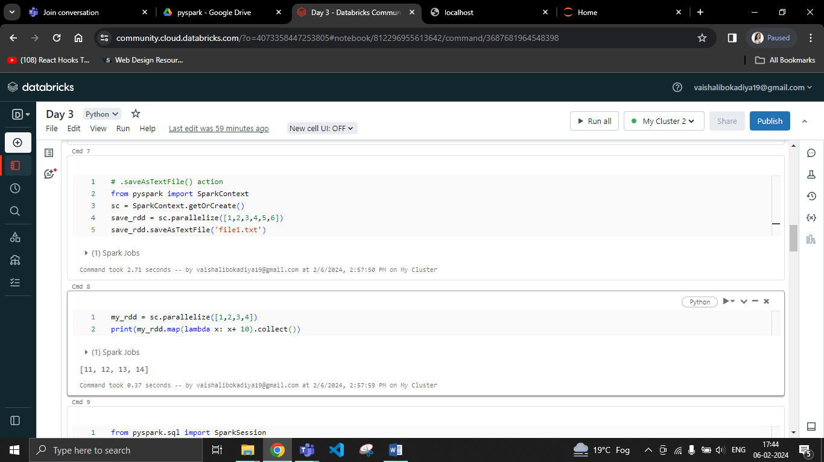

**Creating a Dataframe:**

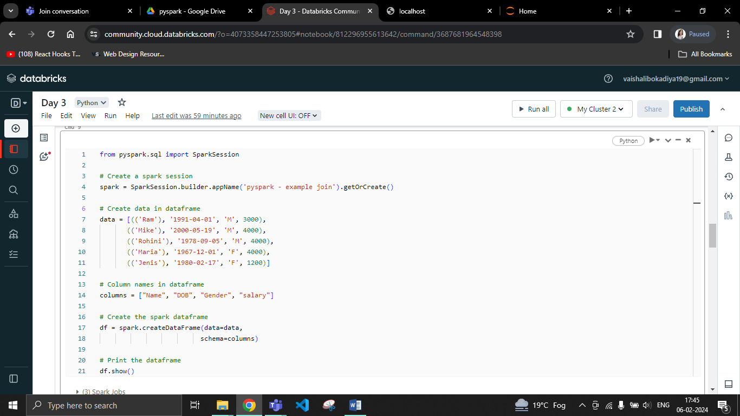

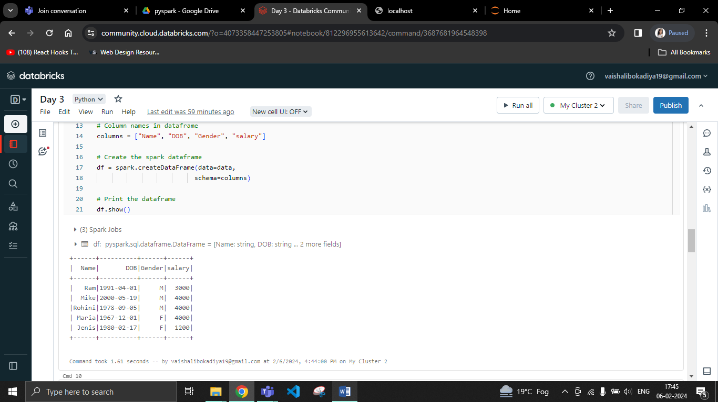

**Rename a column**

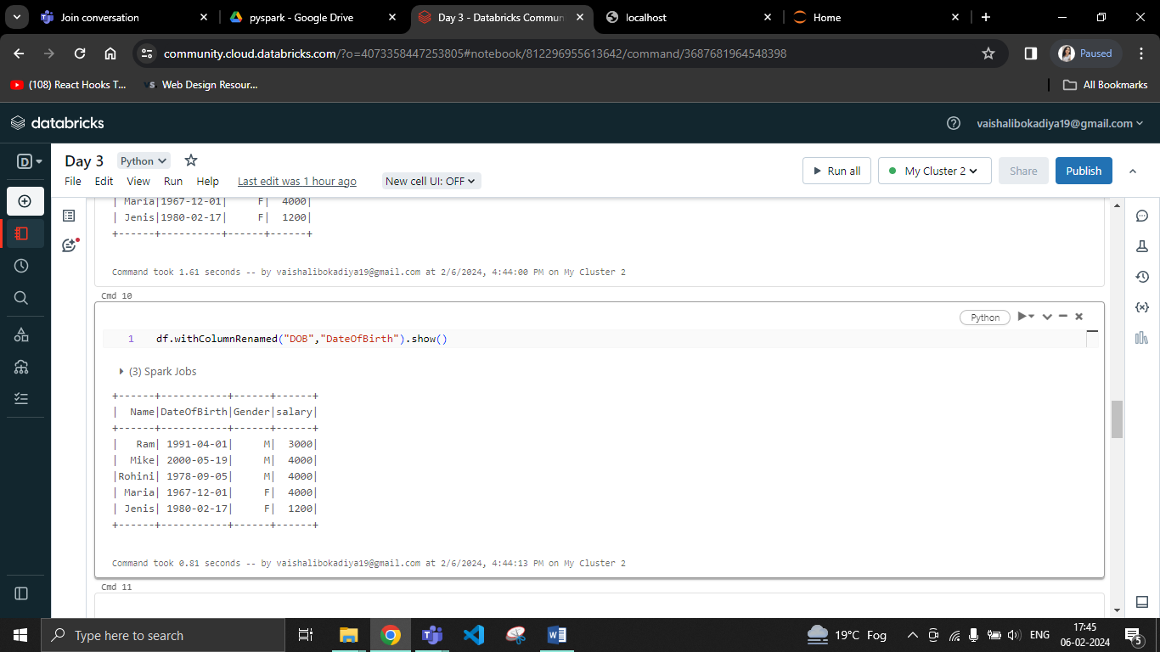

**Rename multiple columns**

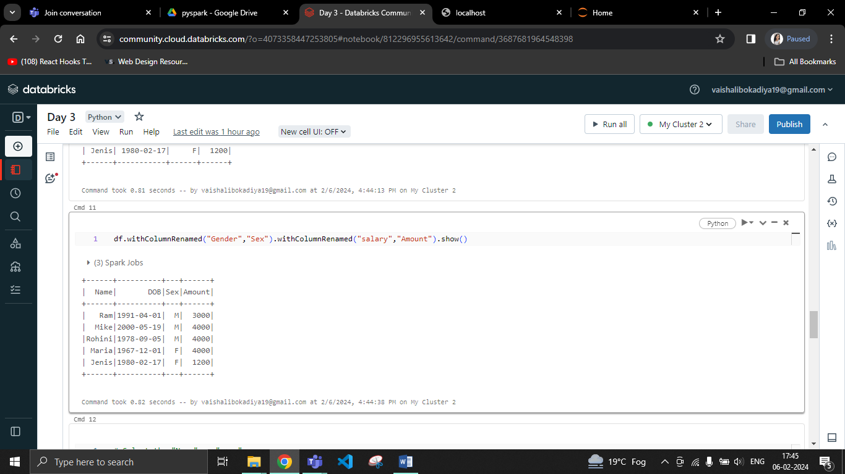

**Using selectExpr()**

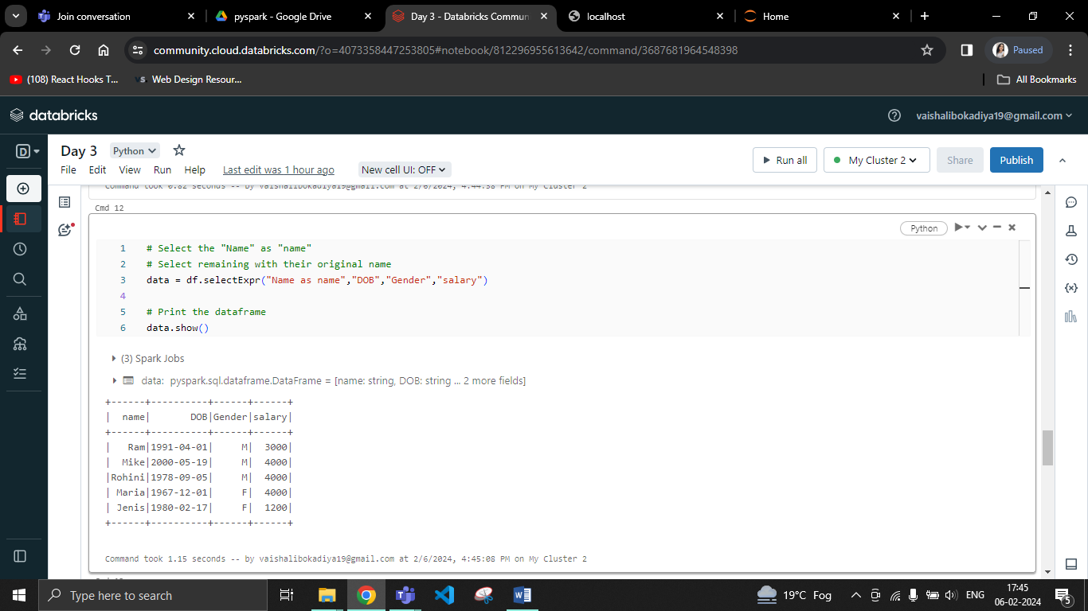

**Using col() method**

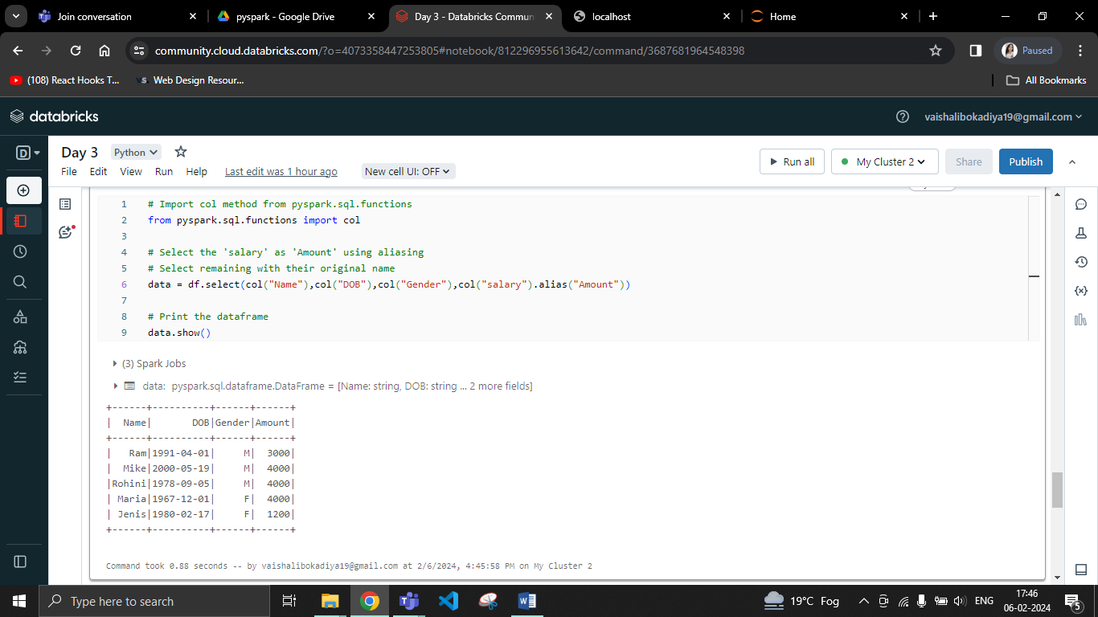

**Using toDF()**

